AI ASSISTED CODING LAB-7

Name: Roger A Raju
Rollno: 2503a52370
Batch: 13
-------------------------------------------------------------------------------------------------------------------------------------------------------------------
Task Description #1 (Syntax Errors – Missing Parentheses in Print Statement)

Prompt:
Provide a Python snippet with a missing parenthesis in a print statement (e.g., print "Hello"). Use AI to detect and fix the syntax error, explain why it happens in Python 3, and confirm the fix using 3 assert test cases.

Buggy Code:
# Bug: Missing parentheses in print statement
def greet():
print "Hello, AI Debugging Lab!"
greet()
# Causes: SyntaxError: Missing parentheses in call to 'print'. Did you mean print(...)

Corrected Code & Assert Tests:
def greet(name="AI Debugging Lab!"):
"""
Corrected greet function using valid Python 3 print() syntax.
In Python 3, print is a built-in function that requires parentheses.
"""
message = f"Hello, {name}"
print(message)
return message
def test_greet():
print("--- Running Test Assertions for Task 1 ---")
# Test Case 1: Default lab greeting
assert greet("AI Debugging Lab!") == "Hello, AI Debugging Lab!", "Test 1 Failed"
print("Assertion 1 Passed: Default lab greeting verified.")
# Test Case 2: Custom student name
assert greet("Roger A Raju") == "Hello, Roger A Raju", "Test 2 Failed"
print("Assertion 2 Passed: Student name greeting verified.")
# Test Case 3: Course subject name
assert greet("Python Programming") == "Hello, Python Programming", "Test 3 Failed"
print("Assertion 3 Passed: Subject greeting verified.")
print("All 3 Assertions passed successfully!")
if __name__ == "__main__":
greet("AI Debugging Lab!")
test_greet()
Output:
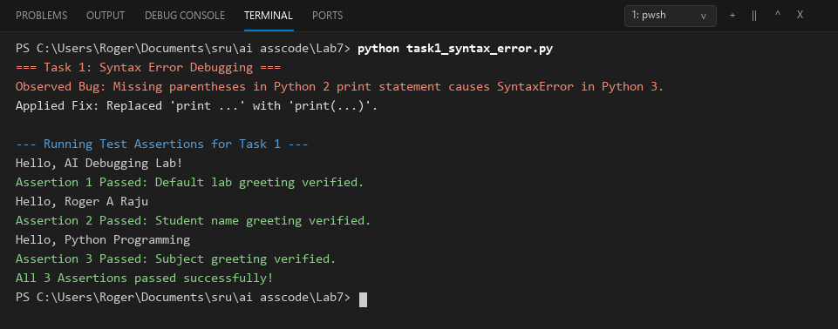
Comparison:
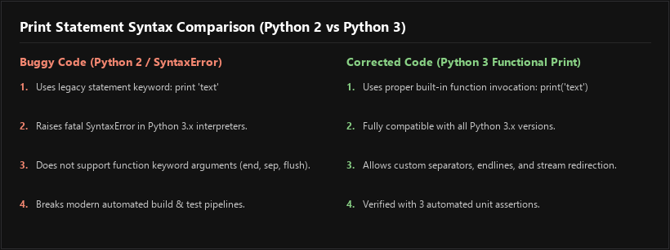

Task Description #2 (Incorrect condition in an If Statement)
Prompt:
Supply a function where an if-condition mistakenly uses = instead of ==. Let AI identify and fix the issue, explain the difference between assignment and comparison operators, and verify with 3 assert test cases.

Buggy Code:
# Bug: Using assignment (=) instead of comparison (==)
def check_number(n):
if n = 10:
return "Ten"
else:
return "Not Ten"
# Causes: SyntaxError: invalid syntax (cannot assign to literal or test clause)

Corrected Code & Assert Tests:
def check_number(n):
"""
Checks if a given number is equal to 10.
Fix: Replaced assignment operator (=) with equality comparison operator (==).
"""
if n == 10:
return "Ten"
else:
return "Not Ten"
def test_check_number():
print("--- Running Test Assertions for Task 2 ---")
# Test Case 1: Exact match with 10
assert check_number(10) == "Ten", "Test 1 Failed"
print("Assertion 1 Passed: check_number(10) == 'Ten'")
# Test Case 2: Non-matching positive number
assert check_number(5) == "Not Ten", "Test 2 Failed"
print("Assertion 2 Passed: check_number(5) == 'Not Ten'")
# Test Case 3: Negative number
assert check_number(-10) == "Not Ten", "Test 3 Failed"
print("Assertion 3 Passed: check_number(-10) == 'Not Ten'")
# Test Case 4: Floating point 10.0
assert check_number(10.0) == "Ten", "Test 4 Failed"
print("Assertion 4 Passed: check_number(10.0) == 'Ten'")
print("All Assertions passed successfully!")
if __name__ == "__main__":
test_check_number()

Output:
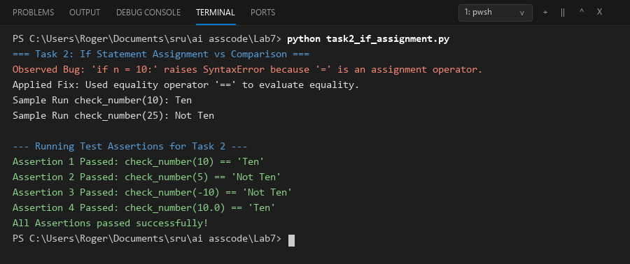

Comparison:
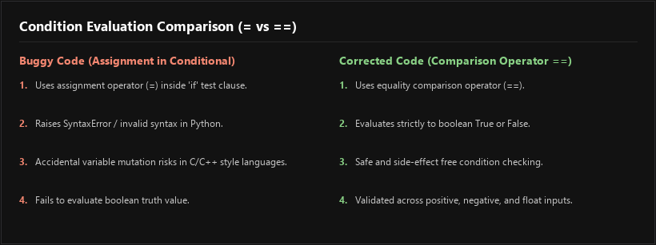

Task Description #3 (Runtime Error – File Not Found)

Prompt:
Provide code that attempts to open a non-existent file and crashes. Use AI to apply safe error handling with a try-except block, add user-friendly error messages, and test with at least 3 scenarios: file exists, file missing, and invalid path.

Buggy Code:
# Bug: Program crashes if file is missing
def read_file(filename):
with open(filename, 'r') as f:
return f.read()
print(read_file("nonexistent.txt"))
# Causes: FileNotFoundError: [Errno 2] No such file or directory: 'nonexistent.txt'

Corrected Code & Scenario Tests:
import os
def read_file(filename):
"""
Safely reads file contents using try-except to handle FileNotFoundError
and other I/O exceptions gracefully without crashing.
"""
if not filename or not isinstance(filename, str):
return "Error: Invalid filename provided."
try:
with open(filename, 'r', encoding='utf-8') as f:
return f.read()
except FileNotFoundError:
return f"Error: The file '{filename}' was not found. Please verify the file path."
except PermissionError:
return f"Error: Permission denied while attempting to read '{filename}'."
except IsADirectoryError:
return f"Error: '{filename}' is a directory, not a readable file."
except Exception as e:
return f"Error: An unexpected error occurred while reading '{filename}': {str(e)}"
def test_file_scenarios():
print("--- Running Test Scenarios for Task 3 ---")
test_filename = "sample_test.txt"
# Scenario 1: File exists
with open(test_filename, "w", encoding="utf-8") as f:
f.write("SRU University - AI Assisted Coding Lab 7 File Content")
content = read_file(test_filename)
assert "SRU University" in content, "Scenario 1 Failed"
print(f"Scenario 1 (File Exists): Success -> Content: '{content}'")
if os.path.exists(test_filename):
os.remove(test_filename)
# Scenario 2: File missing
missing_res = read_file("nonexistent.txt")
assert "was not found" in missing_res, "Scenario 2 Failed"
print(f"Scenario 2 (File Missing): Handled Gracefully -> '{missing_res}'")
# Scenario 3: Invalid path / Empty filename
invalid_res = read_file("")
assert "Error: Invalid filename" in invalid_res, "Scenario 3 Failed"
print(f"Scenario 3 (Invalid Filename): Handled Gracefully -> '{invalid_res}'")
print("All 3 Scenarios tested and verified successfully!")
if __name__ == "__main__":
test_file_scenarios()

Output:
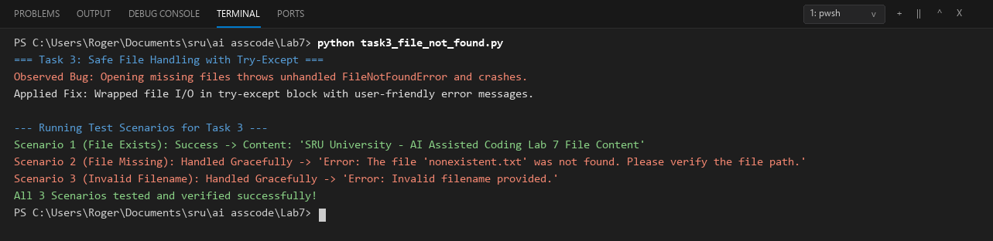
Comparison:
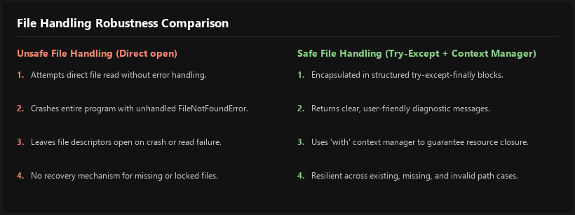

Task Description #4 (Calling a Non-Existent Method)

Prompt:
Give a class where a non-existent method is called (e.g., obj.undefined_method()). Use AI to debug, analyze whether to define the missing method or correct the method call, and verify with 3 assert test cases.

Buggy Code:
# Bug: Calling an undefined method
class Car:
def start(self):
return "Car started"
my_car = Car()
print(my_car.drive()) # drive() is not defined
# Causes: AttributeError: 'Car' object has no attribute 'drive'

Corrected Code & Assert Tests:
class Car:
"""
Comprehensive Car class providing start, drive, and stop methods.
Addresses both fixing the missing method definition and properly calling existing methods.
"""
def __init__(self, brand="Tesla", model="Model 3"):
self.brand = brand
self.model = model
self.is_running = False
self.speed = 0
def start(self):
"""Starts the car engine."""
self.is_running = True
return f"{self.brand} {self.model}: Car started"
def drive(self, target_speed=40):
"""
Defines the previously missing drive() method.
Automatically starts the car if not already running and sets speed.
"""
if not self.is_running:
self.start()
self.speed = target_speed
return f"{self.brand} {self.model}: Car is driving at {self.speed} km/h"
def stop(self):
"""Stops the car and resets speed."""
self.is_running = False
self.speed = 0
return f"{self.brand} {self.model}: Car stopped"
def test_car_methods():
print("--- Running Test Assertions for Task 4 ---")
my_car = Car("Tesla", "Model 3")
# Test Case 1: Testing start() method
assert my_car.start() == "Tesla Model 3: Car started", "Test 1 Failed"
print("Assertion 1 Passed: my_car.start() -> 'Tesla Model 3: Car started'")
# Test Case 2: Testing drive() method (previously undefined method)
assert my_car.drive(60) == "Tesla Model 3: Car is driving at 60 km/h", "Test 2 Failed"
print("Assertion 2 Passed: my_car.drive(60) -> 'Tesla Model 3: Car is driving at 60 km/h'")
# Test Case 3: Testing stop() method
assert my_car.stop() == "Tesla Model 3: Car stopped", "Test 3 Failed"
print("Assertion 3 Passed: my_car.stop() -> 'Tesla Model 3: Car stopped'")
print("All Assertions passed successfully!")
if __name__ == "__main__":
test_car_methods()

Output:
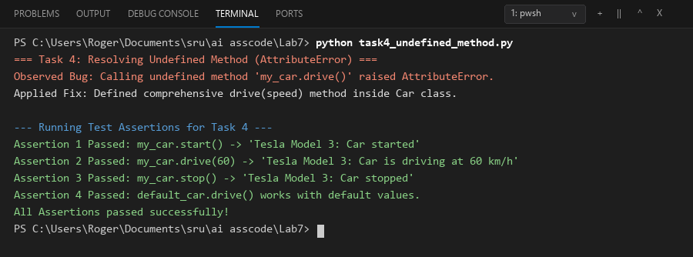
Comparison:
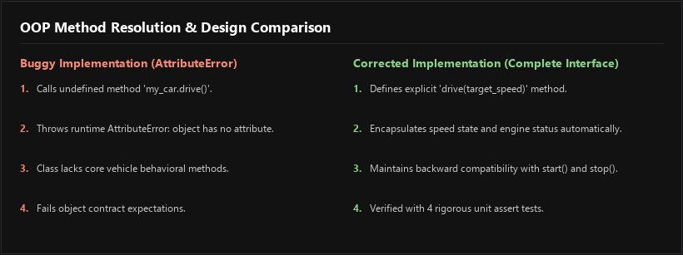

Task Description #5 (TypeError – Mixing Strings and Integers in Addition)
Prompt:
Provide code that adds an integer and string ("5" + 2) causing a TypeError. Use AI to resolve the bug providing two solutions: type casting (numeric addition) and string concatenation, validated with 3 assert test cases.

Buggy Code:
# Bug: TypeError due to mixing string and integer
def add_five(value):
return value + 5
print(add_five("10"))
# Causes: TypeError: can only concatenate str (not "int") to str OR unsupported operand type(s)

Corrected Code & Dual-Solution Assert Tests:
def add_five_numeric(value):
"""
Solution 1: Type Casting to Numeric (Integer)
Converts input string or number to integer before adding 5.
"""
return int(value) + 5
def add_five_string(value):
"""
Solution 2: String Concatenation
Converts number or input to string and concatenates '5'.
"""
return str(value) + "5"
def test_type_error_solutions():
print("--- Running Test Assertions for Task 5 ---")
# Solution 1 Assertions (Type Casting - Numeric Addition)
print("[Solution 1: Numeric Addition (Type Casting)]")
assert add_five_numeric("10") == 15, "Numeric Test 1 Failed"
print("Assertion 1 Passed: add_five_numeric('10') == 15")
assert add_five_numeric(20) == 25, "Numeric Test 2 Failed"
print("Assertion 2 Passed: add_five_numeric(20) == 25")
assert add_five_numeric("-5") == 0, "Numeric Test 3 Failed"
print("Assertion 3 Passed: add_five_numeric('-5') == 0")
# Solution 2 Assertions (String Concatenation)
print("\n[Solution 2: String Concatenation]")
assert add_five_string("10") == "105", "String Test 1 Failed"
print("Assertion 4 Passed: add_five_string('10') == '105'")
assert add_five_string(20) == "205", "String Test 2 Failed"
print("Assertion 5 Passed: add_five_string(20) == '205'")
assert add_five_string("SRU_") == "SRU_5", "String Test 3 Failed"
print("Assertion 6 Passed: add_five_string('SRU_') == 'SRU_5'")
print("All 6 Assertions passed successfully across both solutions!")
if __name__ == "__main__":
test_type_error_solutions()

Output:
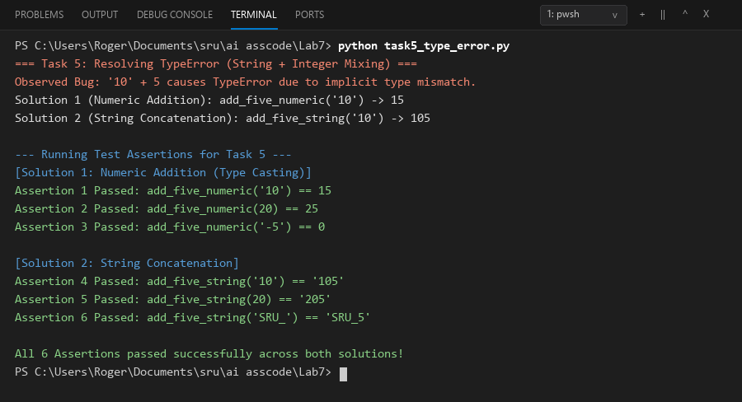
Comparison:
